Progress Report: Sri Lanka Clinical Trials Registry

SLCTR registration number: SLCTR/2015/007

Scientific title of trial: Randomized controlled trial to compare the effectiveness of cyproterone acetate/ethinyl estradiol, desogestrel/ethiyl estradiol and metformin on improving hirsutism, hormonal and metabolic features of polycystic ovary syndrome

Date of commencement (enrolment of first participant): 01/04/2015

Progression: 6 months □ 1 year □ 2 years □ 3 years □

At completion √

- Baseline data

Any changes to the trial design/ methodology/ protocol after commencement: Not changed

Any changes to trial outcomes after commencement: No

- Current status

Recruitment status: pending/ recruiting/ recruitment complete/ recruitment suspended / recruitment terminated

Number assessed for eligibility: 157

Number recruited and allocated/randomized: 107

Number allocated/randomized to each intervention/arm (please edit as relevant):

Arm | Drugs | No of patients
1 | 2 mg of cyproterone acetate and 35 microg of ethinyl estradiol pill daily  placebo pill equal to Metformin SR pill daily  placebo pill equal to desogestrel 0.15mg/ ethinyl estradiol(20 microg) pill daily | 25
2 | desogestrel 0.15mg/ ethinyl estradiol(20 microg) daily  placebo pill equal to metformin SR pill daily  placebo pill equal to 2 mg of cyproterone acetate and 35 microg of ethinyl estradiol pill daily | 25
3 | metformin (SR) daily  2 mg of cyproterone acetate and 35 microg of ethinyl estradiol daily  placebo pill equal to desogestrel 0.15mg/ ethinyl estradiol(20 microg) pill daily | 26
4 | metformin(SR) daily  desogestrel 0.15mg/ ethinyl estradiol(20 microg) daily  placebo pill equal to 2 mg of cyproterone acetate and 35 microg of ethinyl estradiol pill daily | 31

Losses/exclusions after allocation/randomization (please edit as relevant): 8

- Trial output

Date of trial completion (“last patient, last visit”): 01/04/2017
Final sample size: 107
Summary of Interim/Final data (if available):

Introduction
The combined oral contraceptive pill (COCP) and metformin constitute the mainstay of drug therapy for Polycystic Ovary Syndrome(PCOS). The effects of COCP and metformin on the clinical problems of PCOS remain ill understood.
Objectives
To determine the effects of cyproterone acetate (2mg)/ethinylestradiol (35 microg) (EE/CPA) and desogestrel 0.15mg/ethinylestradiol (20 microg) (EE/DES), alone or in combination with metformin on hirsutism, metabolic and biochemical parameters of patients with PCOS.
Methodology
This study was aA double-blind, randomised, parallel group study. One hundred and seven patients were randomised to receive either of four drug combinations (arm A - EE/CPA, arm B-EE/DES, arm C-EE/CPA plus metformin, arm D-EE/DES plus metformin). Inclusion criteria were PCOS diagnosed by Rotterdam Criteria 2003 and hirsutism score ≥8 by modified Ferriman-Gallwey Score (mFGS). Exclusion criteria included secondary causes of hyperandrogenism. Sample size was calculated based on previous similar studies. Hirsutism was (assessed by mFGS, outer hair diameter, hair growth rate and hair density of sideburns and chin), anthropometry, blood pressure, oral glucose tolerance test, fasting insulin, HOMA-IR, HOMA–β, total testosterone, sex hormone binding globulin, leptin, free androgen index, lipid profile, visceral adiposity index, ovarian volume and patient quality of life were assessed at initiation, 6 months and 12 months of the trial. Statistical analysis was by two way ANOVA.
Results
Ninety nine women completed the trial and six dropped out due to adverse effects of drugs. Baseline variables were randomly distributed except age. There was no significant difference in outcomes betweem the four treatment arms at 12 months with regard to all the variables. However, there was a significant reduction in BMI, hair density and mFGS in arm A, mFGS and HOMA-β in arm B, leptin and hair density in arm C and diameter of sideburns hair in arm D at the end of 12 month. There was a significant increase in hair growth rate of chins in all four arms, total cholesterol and HDL cholesterol in arms B and D. Ovarian volume was significantly reduced and quality oflife significantly improved in all four arms.
Conclusion
EE/CPA and EE/DES were equally effective in improving hirsutism, hormonal and metabolic features of PCOS. Metformin did not show an additional effect. . All women were satisfied about their status of hirsutism at the end of twelve months of therapy with cyclical hormonal therapy.

Abstract presentations of results at scientific meetings
Note: please include a URL link or scanned copy of the abstract
Title of Abstract | Full citation (please include authors, date, title of conference and place of presentation, page number of abstract).
Effectiveness of Low Dose Ethinyl/Cyproterone Acetate, Ethinyl Estradiol/ Desogestrel and Metformin on Hirsutism in Polycystic Ovary Syndrome: A Randamised Double – Blind Study (Attachment 1) | S Fonseka, CN Wijerathne, IB Gawarammana, NS Kalupahana, S Rosairo, N Ranatunga, PVR Kumarasiri. Effectiveness of Low Dose Ethinyl/Cyproterone Acetate, Ethinyl Estradiol/ Desogestrel and Metformin on Hirsutism in Polycystic Ovary Syndrome: A Randamised Double – Blind Study. Annual Academic Session of Sri Lanka College of Dermatologists; 2018 (26), p56.

Publications
Note: please include a URL link or scanned copy of the publication
Title of paper | Full citation (please include authors, title of journal, volume, issue and page numbers, and/or DOI)
Effects of Ethinylestradiol/Cyproterone Acetate and Ethinylestradiol/Desogestrel Alone and in Combination with Low-Dose Metformin on Glucose and Lipid Homeostasis and Androgenic Hormone Profile in Hirsute Women with Polycystic Ovary Syndrome: A Randomized, Double-Blind, Triple-Dummy Study  URL : https://www.scirp.org/pdf/JBM_2019081315060718.pdf | Fonseka, S., Bandara, D.D.J., Wijeyaratne, C.N., Gawarammana, I.B., Kalupahana, N.S., Rosairo,S. and Kumarasiri, R. (2019) Effects of Ethinylestradiol/Cyproterone Acetate andEthinylestradiol/Desogestrel Alone and in Combination with Low-Dose Metformin on Glucose and Lipid Homeostasis and Androgenic Hormone Profile in Hirsute Women with Polycystic Ovary Syndrome: A Randomized, Double-Blind, Triple-Dummy Study. Journal of Biosciences and Medicines,7, 13-26. https://doi.org/10.4236/jbm.2019.78002

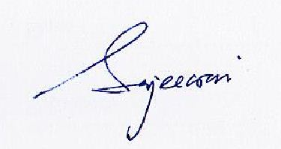
………………………………………………………………………..
Name and signature of Responsible Registrant/
Principal Investigator

Date: 30/08/2019

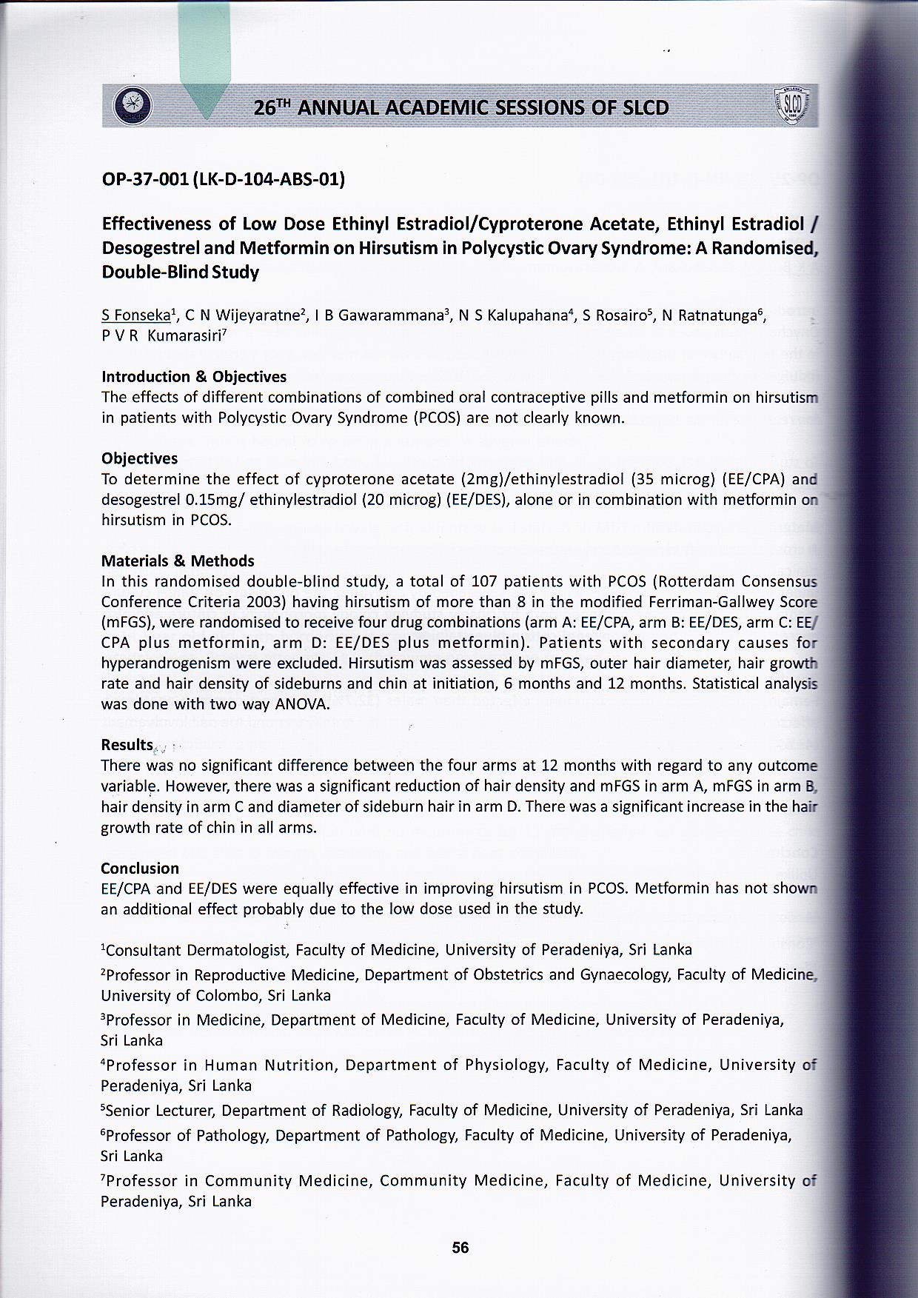
Attachment 1

