Progress Report: Sri Lanka Clinical Trials Registry

SLCTR registration number: SLCTR/2011/006

Scientific title of trial:Oral Montelukast versus inhaled steroids for mild persistent asthma among 1 to 5 year old children

Date of commencement (enrolment of first participant): 9th December 2011

Progression: 18 months □

At completion □

- Baseline data

Any changes to the trial design/ methodology/ protocol after commencement:None except the study period

Any changes to trial outcomes after commencement: None

- Current status

Recruitment status: pending/ recruiting/ recruitment complete: follow up continuing/ recruitment complete: follow up complete/ recruitment suspended / recruitment terminated
Recruitment completed and follow up completed

Number assessed for eligibility: 110

Number recruited and allocated/randomized:81 (eighty one)

Number allocated/randomized to each intervention/arm (please edit as relevant):

Arm 1: 35 ( Thirty five)

Arm 2: 46 (fourty six)

Losses/exclusions after allocation/randomization (please edit as relevant):

Arm 1: 05 ( five)

Arm 2: 15 (fifteen )

- Trial output
Date of trial completion (“last patient, last visit”): Last patient recruited on 15th
February 2013 and the last visit was on 31st May 2013
Final sample size: 61 (sixty one)

Oral Montelukast versus inhaled steroids for mild persistent asthma among 1 to 5 year old
children
Jayawardena PP 1 , Imalke KACP 2 Galappaththi J 3
1 Senior Lecturer, Department of Paediatrics, Faculty of Medicine, University of Ruhuna, Galle.
2 Probationary Lecturer, Department of Paediatrics, Faculty of Medicine, University of Ruhuna.
3 Medical officer Base, Hospital, Elpitiya

BACKGROUND
Bronchial Asthma (BA) is a common childhood disease. Inhaled corticosteroids (ICS) were the
standard prophylactic treatment. Montelukast (MLK)-a leukotriene antagonist was considered as
an adjunct therapy.
OBJECTIVE
The objective of this study is to compare the efficacy of MLK as a monotherapy verses ICS for
mild persistent bronchial asthma in 1 to 5 years.
METHODOLOGY
This is a randomized comparative study.
Patients with mild persistent asthma attended to asthma clinic Faculty of medicine Karapitiya
were randomized in to two groups (n=80). Two groups were treated with ICS and MLK. They
were monitored in the clinic for 100 days. Parents were educated to maintain a symptom diary.
Based on the diary symptomatic improvement was considered with respect to cough, wheeze,
and nasal congestion and physical activities giving scores from 0-3 for each symptom each day
(i.e. maximum score for 100 days was 300). Increasing of score indicates the better outcome.
RESULTS
There were no statistical significant differences in socio demographic data between two groups.
There were five dropouts from each group and five and four treatment failures in ICS and MLK

groups respectively. The mean cough score in ICS group (30) was 278.23 and in MLK group
(31) was 278.74 with no statistical significant difference (P=0.938). The mean wheeze scores
were 293.63 and 287.26 in ICS and MLK group respectively with no significant difference
(P=0.17).Compared to mean nasal congestion score in ICS group (251.3), MLK group (281.4)
had statistical significant difference (P&lt;0.05).With regard to physical activity the mean scores
were 289.6 and 292.2 in ICS and MLK group respectively with no significant difference
(P=0.53).
Conclusion
Montelukast is equally effective as inhaled corticosteroids in prevention of mild persistent
asthma among 1-5 years and additional significant benefit in controlling rhinitis symptoms.
Summary of Interim/Final data (if available):

Abstract presentations of results at scientific meetings
Note: please include a URL link or scanned copy of the abstract
Title of Abstract | Full citation (please include authors, date, title of conference and place of presentation, page number of abstract).
Oral Montelukast versus inhaled steroids for mild persistent asthma among 1 to 5 year old  children | Galle Medical Association 2014  Jayawardena PP 1 , Imalke KACP 2 Galappaththi J 3  1 Senior Lecturer, Department of Paediatrics, Faculty of Medicine, University of Ruhuna, Galle  .2 Probationary Lecturer, Department of Paediatrics, Faculty of Medicine, University of Ruhuna.  3 Medical officer Base, Hospital, Elpitiya
Oral Montelukast versus inhaled steroids for mild persistent asthma among 1 to 5 year old  children | Sri Lanka College of Paediatrics 2015  Jayawardena PP 1 , Imalke KACP 2 Galappaththi J 3  1 Senior Lecturer, Department of Paediatrics, Faculty of Medicine, University of Ruhuna, Galle  .2 Probationary Lecturer, Department of Paediatrics, Faculty of Medicine, University of Ruhuna.  3 Medical officer Base, Hospital, Elpitiya

Publications
Note: please include a URL link or scanned copy of the publication
Title of paper | Full citation (please include authors, title of journal, volume, issue and page numbers, and/or DOI)

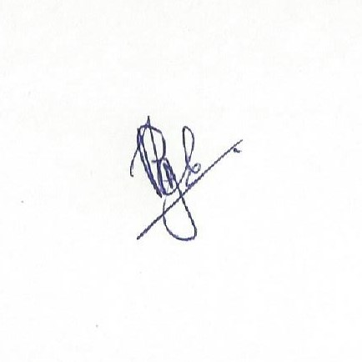
………………………………………………………………………..
Name and signature of Responsible Registrant/
Principal Investigator

Date:11.08.2020

