Progress Report: Sri Lanka Clinical Trials Registry

SLCTR registration number: SLCTR/2020/019

Scientific title of trial: Computer Assisted Rehabilitation in Improving Hand Function in Patients with Stroke

Date of commencement (enrolment of first participant):

Progression: 6 months □ 1 year √ 2 years □ 3 years □

At completion □

- Baseline data

Any changes to the trial design/ methodology/ protocol after commencement: No

Any changes to trial outcomes after commencement: No

- Current status

Recruitment status: pending/
Number assessed for eligibility: Recruitment postponed due to Covid-19 pandemic will be started from June 2022

Number recruited and allocated/randomized: N/A

Number allocated/randomized to each intervention/arm (please edit as relevant):

Arm 1: N/A

Arm 2:

Losses/exclusions after allocation/randomization (please edit as relevant):

Arm 1: N/A

Arm 2:

- Trial output

Date of trial completion (“last patient, last visit”): N/A
Final sample size:

Summary of Interim/Final data (if available):
All the equipment required were purchased. However due to the Covid -19 pandemic the practicalities of recruitment and potential harm to the subjects and investigators were considered and recruitment is postponed

Abstract presentations of results at scientific meetings
Note: please include a URL link or scanned copy of the abstract
Title of Abstract | Full citation (please include authors, date, title of conference and place of presentation, page number of abstract).

Publications
Note: please include a URL link or scanned copy of the publication
Title of paper | Full citation (please include authors, title of journal, volume, issue and page numbers, and/or DOI)

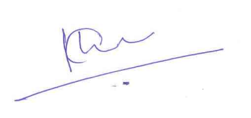

………………………………………………………………………..
Name and signature of Responsible Registrant/
Principal Investigator

Date: 22.05.2022

