Progress Report: Sri Lanka Clinical Trials Registry

SLCTR registration number: SLCTR/2024/024
Scientific title of trial: Efficacy of a group mindfulness intervention in improving psychological wellbeing among a stratified random sample of individuals, who have been serving the Sri Lanka army during the civil war

Date of commencement (enrolment of first participant): 1st October 2024

Progression: 6 months x 1 year □ 2 years □ 3 years □

At completion □

- Baseline data

Any changes to the trial design/ methodology/ protocol after commencement: A high rate of drop outs were seen at the beginning. Therefore, it has been proposed to introduce a certificate of participation stating the participation in the 8-week mindfulness program. This has been discussed with the supervisors and been informed to the ERC as well.

Any changes to trial outcomes after commencement: None.

- Current status

Recruitment status: pending/ recruiting/ recruitment complete: follow up continuing/ recruitment complete: follow up complete/ recruitment suspended / recruitment terminated

Number assessed for eligibility:30

Number recruited and allocated/randomized: 16

Number allocated/randomized to each intervention/arm (please edit as relevant): N/A

Arm 1:

Arm 2:

Losses/exclusions after allocation/randomization (please edit as relevant):

Arm 1:12 (Drop Outs)

Arm 2:

- Trial output

Date of trial completion (“last patient, last visit”):
Final sample size:

Summary of Interim/Final data (if available):

Abstract presentations of results at scientific meetings – N/A
Note: please include a URL link or scanned copy of the abstract
Title of Abstract | Full citation (please include authors, date, title of conference and place of presentation, page number of abstract).
Publications
Note: please include a URL link or scanned copy of the publication
Title of paper | Full citation (please include authors, title of journal, volume, issue and page numbers, and/or DOI)

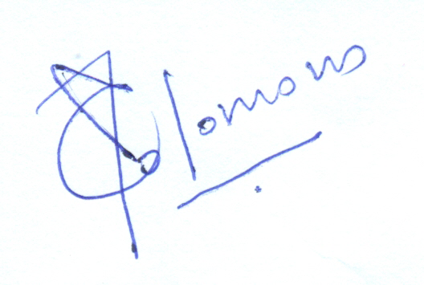Tina Solomons

Name and signature of Responsible Registrant/
Principal Investigator

Date:2025/03/20

